Suggested core spelling curriculum

This curriculum map organises the statutory spelling rules/patterns, as well as the statutory lists of words to learn across KS2, into half termly objectives.
Space is left in the curriculum for teachers to focus on dictation, topic words, revision and bespoke work as appropriate.
The curriculum map is organised using the following key spelling strands:

Spelling principles used as strands | 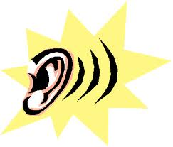 Phonemic knowledge  Knowledge of grapheme-phoneme correspondences is crucial for effective spelling.
Visual and semantic knowledge
Approaches that emphasise overlearning for memory, visual methods and knowledge of context are useful here.
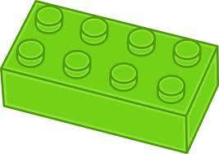 Morphological and etymological knowledge
Morphology is the study of words and how they are formed. Morphology analyses parts of words (morphemes), such as root words, prefixes and suffixes.
Etymology is the study of the origin of words.

Year R within the EYFS
Early Learning Goal: Children use their phonic knowledge to write words in ways which match their spoken sounds. They also write some irregular common words. They write simple sentences which can be read by themselves and others. Some words are spelt correctly and others are phonetically plausible.
40-60 months
- Gives meaning to marks they make as they draw, write and paint.
- Begins to break the flow of speech into words.
- Continues a rhyming string.
- Hears and says the initial sound in words.
- Can segment the sounds in simple words and blend them together.
- Links sounds to letters, naming and sounding the letters of the alphabet.
- Uses some clearly identifiable letters to communicate meaning, representing some sounds correctly and in sequence.
- Writes own name and other things such as labels, captions.
- Attempts to write short sentences in meaningful contexts.
Based on the expectations above, the main thrust of teaching spelling in Year R is securing:
- the understanding that words can be segmented in to sounds
- the understanding that graphemes (letters or groups of letters) represent sounds
- the ability to hear rhymes and to hear syllables in words
- good letter formation to build fluency in handwriting
- the understanding that some high frequency words are not phonetically plausible and are best learned through regular writing practice to build muscle memory and automaticity.
A school should ensure that its phonics programme includes practice at reading and spelling HFWs from Year R and throughout KS1 and that children’s ability is tracked regularly.
To create readiness for phase 5 phonics in Year 1, a Year R programme should aim to secure:
- Segmenting to spell all phonemes from phase 2 and 3, including words using adjacent consonants
- Being able to spell the tricky words he, she, we, me, be, was, my, you, her, they, all, are (these words can vary slightly between different phonics programmes)

 |  | Year 1 | Year 2 |  | Year 3 |  |  | Year 4 | Year 5 |  | Year 6
Autumn 1 |  | Revision: closing any gaps in using phonics for spelling from previous phases  Adjacent consonants | Revision: closing any gaps in using phonics for spelling from previous phases  Securing phase 5 GPCs in spelling |  | Revision as needed  Best guess, investigation and word families for spelling alternative GPCs  Use pupils’ writing to decide on priority areas |  |  |  | Review importance of hearing syllables and stressed and unstressed vowels to support spelling  Words from Year 5/6 list  average, awkward, category cemetery, controversy, definite, desperate, develop, dictionary, embarrass, familiar, necessary, secretary, vegetable, harass, suggest, system
 |  | 100 HFW  Common exception words (CEW) for Year 1 | 100 HFW  Common exception words (CEW) for Year 2  Begin to distinguish between homophones and near homophones (e.g. there/their/they’re, here/hear, quite/quiet, one/won, sun/son, to/too/two, be/bee) |  | 200 HFW  Use word class/function where possible to make distinctions e.g. there/where/here  two/twelve/twenty  Selected words from statutory NC list (Year 3/4) |  |  | 200 HFW  Our commonly misspelt words: what cues could we use to learn them?  Selected words from statutory NC list (Year 3/4) | Homophones linked to word class/function  Investigating patterns in verb and noun spellings  e.g.  license/licence  devise/device  practise/practice  advise/advice  Selected words from statutory NC list (Year 5/6) |  | Homophones linked to word class/function e.g.  affect verb/ effect noun  guessed verb/ guest noun  passed verb/ past noun  Selected words from statutory NC list (Year 5/6)
 |  | Compound words | Review –ed and –ing as verb inflections |  | Review root words and affixes: -ed, -ing,  -ly, -er, -est, -ness, -ful  (see NC Appendix 1)  Revise apostrophes for contracted forms |  |  | Dictionary work  Plural and possessive ‘s’ | Verb prefixes e.g. dis-, de-, mis-, over-, re- |  | Synonym and antonym word families: which words have opposites and are there options?  ough – can be pronounced 7 different ways: look for patterns in Viking root words (gh used to be pronounced as ch in loch)
Autumn 2 |  | Phase 5 GPC | Securing phase 5 GPCs in spelling: best guess and word families  Using syllables to support spelling |  | Best guess, investigation and word families for alternative GPCs  Syllables: stressed and unstressed vowels. Vowels in red cannot be reliably heard (words from statutory 3/4 list):  calendar, decide, describe, different, difficult, exercise, experience, forward(s), grammar, sentence, separate, medicine, particular, peculiar, ordinary, popular, pressure, probably, purpose, regular |  |  |  | Words from statutory list with unusual GPC:  amateur ancient, attached, bargain, bruise, determined, embarrass, foreign, forty, necessary, guarantee, rhyme, rhythm, stomach, individual, language, leisure, lightning, neighbour, persuade, privilege, programme, queue, restaurant, shoulder, soldier, thorough, vehicle, yacht
With the word groups above, sound cues alone will let the learner down. Cues to try:
- Groups of words with the same grapheme/letter string (e.g. bruise, cruise; shoulder, boulder, smoulder)
- Overpronunciation (bar – gayn, sto-match, ve-hicle)

 |  | HFW/CEW  Spell the days of the week | HFW/CEW  Homophones |  | HFW/Statutory list words  Further homophones  Visual cues: look, say, cover, write, check |  |  |  | Statutory list words  Homophones and commonly misspelt words  Visual cues: look, say, cover, write, check
 |  | Introduce root words and affixes: use -ing and -ed where no change is needed in the spelling of root words | -er and –est to form comparative adjectives  -ly to turn adjectives into adverbs |  | Dictionary work  Forming nouns from prefixes  Explore links between words: medical/medicine  Word matrices/webs could be used effectively here |  |  | Review adding –ly to form an adverb. Investigate exceptions to the rule  French roots in chef, chalet, machine, brochure  league, tongue, unique antique | Verb suffixes (noun to verb) e.g. –ate, -ise, -ify  Silent letters linked to etymology – used to be pronounced.  Look at word families and how pronunciation can shift  e.g. knight, doubt, lamb, solemn, island |  | Words from statutory list with a root that can be built in to a word web: achieve, aggressive, communicate, community, committee, conscience* conscious*, criticise (critic + ise), definite, dictionary (dictate, diction), environment, familiar, muscle (muscular), physical, rhyme, rhythm, sacrifice, signature (sign, design, signal), twelfth (two, twelve, twenty), symbol, occupy, occur, temperature.
Spring 1 |  | Phase 5 GPC | Securing phase 5 GPCs in spelling  Syllables |  | Alternative graphemes for /eɪ/ (/ay/) sound (vein, weigh, eight, neighbor, they, obey)
 |  | 100 HFW/CEW | 100 HFW/CEW  Homophones |  | HFW/Statutory list words  Homophones:  accept/except, affect/effect, ball/bawl, berry/bury, brake/break, fair/fare, grate/great, groan/grown, here/hear, heel/heal/he’ll, knot/not, mail/male, main/mane, meat/meet, medal/meddle, missed/mist, peace/piece, plain/plane, rain/rein/reign, scene/seen, weather/whether, whose/who’s |  |  |  | Statutory list words  Homophones and commonly mis-spelt words
 |  | -s and –es for plurals  Introduction to contracted forms (e.g. don’t) | -ful and -less to form adjectives  Word matrices/webs could be used effectively here  Apostrophes for common contracted forms e.g.  can’t, didn’t, hasn’t, couldn’t, it’s, I’ll |  | Roots and affixes –  Prefixes for opposites or negatives:  un-, dis-, mis-, anti-  Word matrices/webs could be used effectively here |  |  | Review apostrophe use and include use for possession with plural nouns and those ending in ‘s’  Plural nouns of words ending in ‘o’ (hero, heroes) | Adding suffix: able/ible to make adjectives  Investigate if there is a best guess according to the nature of the root word  Etymological and morphological approaches to NC content (e.g. word matrices) |  | Formal equivalents  e.g  find out – discover  ask for – request  go in – enter  Use of the hyphen (re-enter, co-own)
Spring 2 |  | Phase 5 GPC | Securing phase 5 GPCs in spelling  Syllables |  | y as I  myth, gym, Egypt, pyramid, mystery
 |  | 100 HFW/CEW  Revision of days of the week spellings | 100 HFW/CEW  Homophones |  | 200 HFW/Statutory list words  Homophones |  |  |  | Statutory list words  Homophones and commonly mis-spelt words
 |  | Revision of suffix –ing and –ed | -ness and -er to form nouns  Suffix -ment  Word matrices/webs could be used effectively here  Apostrophe for singular possession |  | Roots and affixes – suffixes – adding to words of more than 1 syllable: doubling consonant depends on where the stress is placed in the word e.g.  beginning  limiting  Explore and accurately use word families based on common words, showing how words are related in form and meaning e.g. solve, solution, solver, dissolve, insoluble  Word matrices/webs could be used effectively here |  | Roots and affixes  Adding -ous suffix  Roots and affixes – how roots create a family: word webs  e.g. solve (solution, solver, dissolve, insoluble  sign (signal, design, designate, signify)  long (length))  strong(strength)  pose (oppose, impose, suppose)  Classical roots in -  Greek: scheme, chorus, chemist, echo  Latin: science, scene, discipline, fascinate, crescent  Etymological and morphological approaches to NC content (e.g. word matrices) |  | Suffixes  -ant/-ance/-ence  for making nouns  -ent for making adjectives  Investigate if there is a best guess according to the nature of the root word  Etymological and morphological approaches to NC content (e.g. word matrices) |  | Words from statutory list where seeing affixes can help in learning correct spelling  Prefix:  accommodate, accompany, according, apparent, appreciate, conscience* conscious*, correspond, recommend, interfere, interrupt  Suffix:  available,  competition, explanation, pronunciation, profession,  convenience, hindrance,  criticise (critic + ise),  curiosity, identity, opportunity  disastrous, marvelous, mischievous  environment, government, equip (–ment), parliament  exaggerate,  excellent, sufficient, relevant  existence, nuisance,  especially, frequently, immediate(ly), sincere(ly)
Summer 1 |  | Phase 5 GPC |  | Securing phase 5 GPCs in spelling  Syllables |  | Alternative phonemes for ‘ou’ grapheme  young, touch, double, trouble, country
 |  | 100 HFW/CEW |  | 100 HFW/CEW  Homophones |  | Words from statutory yr 3/ 4 list with unusual GPC:  answer, build, breath, breathe, believe, caught, consider, continue, decide, early, earth, eight/eighth, weight, enough (Anglo Saxon: rough, tough), exercise, famous/various, island favourite, February, fruit, group, guard, guide, heard, heart, height, history, imagine, learn, material, minute, naughty, notice, often, particular, perhaps (tends not to be pronounced in a way that matches spelling, even though GPC not unusual), potatoes, promise, purpose, quarter, recent, reign, special, straight, surprise, though/although, thought, through, woman/women |  |  |  | Statutory list words  Homophones and commonly misspelt words (see NC Appendix 1)  As sound cues alone will let the learner down, either use:  - Groups of words with the same grapheme/letter string (e.g. exercise, precise; group, soup)  - Overpronunciation (faymouse, Febrooarry, bel-eye-eve)  - Visual cues: Look, Say, Cover, Write, Check
 |  | -er to make nouns (helper) and adjectives (faster)  -est to make adjectives (slowest) |  | Suffix revision (see NC Appendix 1)  Word matrices/webs could be used effectively here |  | Roots and affixes (see NC Appendix 1)  Prefixes: more opposites  il-, ir-, im –  Word matrices/webs could be used effectively here  Review apostrophe for possession | Roots and affixes (see NC Appendix 1)  Adding –tion, -sion, -cian  (explore music→musician, magic→magician etc.)  Etymological and morphological approaches to NC content (e.g. word matrices) |  |  | Suffixes cial/tial for making adjectives  Investigate if there is a ‘best guess’ according to the nature of the root word  Etymological and morphological approaches to NC content (e.g. word matrices) | Further root words and affixes  Adding suffixes beginning with vowel letters to words ending in –fer (transferring, transferred reference, referee – see NC Appendix 1)  Etymological and morphological approaches to NC content (e.g. word matrices)
Summer 2 |  | Phase 5 GPC |  | Securing phase 5 GPCs in spelling  Syllables |  | Review application of best guess for GPC as needed – use pupils’ own issues in writing to drive sessions
 |  | 100 HFW/CEW |  | 100 HFW/CEW  Homophones |  | 200 HFW/Statutory list words  Homophones |  |  |  | Statutory list words  Homophones and commonly misspelt words
 |  | Prefix -un |  | Words ending in -tion (station, fiction, motion, national, section)  Morphological approaches to NC content (e.g. word matrices) |  | More prefixes:  super-, auto-, inter-, sub- | Review – what do we know about adding prefixes and suffixes? |  |  | Suffixes cious/tious for making adjectives: investigate if there is a best guess according to the nature of the root word  Words with the /i:/ sound (/ee/) spelt ei after c and exceptions (deceive, receive)  Etymological and morphological approaches to NC content (e.g. word matrices) | Word origins focus.  Etymological and morphological approaches to NC content (e.g. word matrices)
Words from statutory list with affixes:
Prefix: accident, address, bicycle, disappear, increase, interest, important, remember
Suffix: accidentally, actually, probably, occasion(ally), busy/business, complete, experiment, extreme, mention, position, question, possess(ion), possible, various, famous
Morphological approaches to NC content (e.g. word matrices)

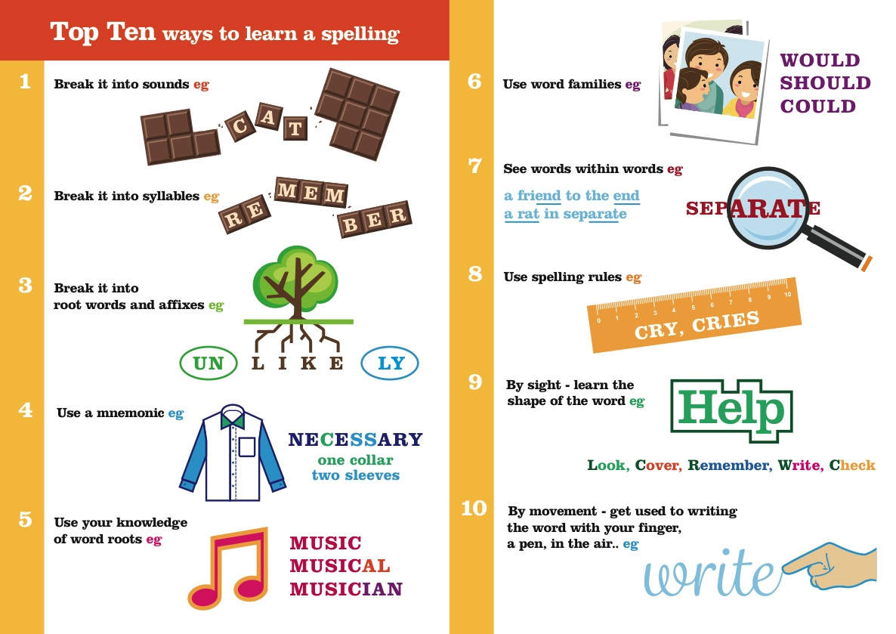

Coding frame for analysis of spelling
Can be used for single pupils, sub-groups or teaching groups to arrive at priority targets for teaching and student review
Spelling principles used as strands | Phonemic knowledge
 | Visual and semantic knowledge
 | Morphological and etymological knowledge
Sound based error
Omission of phoneme
Plausible spelling, wrong grapheme choice
Long vowel sound
Error in unstressed vowels
Common words
homophones
Common irregular (e.g. who, he, one)
Commonly misspelt (e.g. thought, believe, minute)
Root words and affixes
Omission of affix –ed, -ing, -s
Ending: -s, -ing, -ed to words ending in y
Ending: verbs which end in e: adding -ing or other
Ending: adverb formation error with -ly or -ally
Ending: other suffix formations (e.g. ful, ible, able)

Common Exception Word/High Frequency Word/Tricky Word
Crossover Resources

Common Exception Words

Green = 100 HFW list from Letters and Sounds
Italics = Letters and Sounds tricky word (phase dependent)

Year 1 Common Exception Words

the, a, do, to, today, of, said, says, are, were, was, is, his, has, I, you, your, they, be, he, me, she, we, no, go, so, by, my, here, there, where, love, come, some, one, once, ask, friend, school, put, push, pull, full, house, our

Year 2 Common Exception Words
door, floor, poor, because, find, kind, mind, behind, child, children, wild, climb, most, only, both, old, cold, gold, hold, told, every, everybody, even, great, break, steak, pretty, beautiful, after, fast, last, past, father, class, grass, pass, plant, path, bath, hour, move, prove, improve, sure, sugar, eye, could, should, would, who, whole, any, many, clothes, busy, people, water, again, half, money, Mr, Mrs, parents, Christmas

Letters and Sounds High Frequency Words

Italics = Letters and Sounds tricky word
Red = Year 1 common exception word
Blue = Year 2 common exception word
Phase 2

A | an | as | at | If | in
Is | it | of | off | on | can
dad | had | back | and | get | big
him | his | not | got | up | mum
but | the | to | I | no | go
into

Phase 3

will | that | this | then | them | with
see | for | now | down | look | too
he | she | we | me | be | was
you | they | all | are | my | her

Phase 4

went | it’s | from | children | just | help
said | have | like | so | do | some
come | were | there | little | one | when
out | what

Phase 5

don’t | old | I’m | by | time | house
about | your | day | made | came | make
here | saw | very | put | oh | their
people | Mr | Mrs | looked | called | asked
could

Year 3/4 statutory word list sorted into learning categories
Possible approach to learning | Words from statutory list | Helpful guidelines
Root word + prefix | Accident, address, bicycle, disappear, increase, interest, important, remember | Although roots of accident and address no longer used, ac + cident and ad + dress helps to explain the double letters.
Root word + suffix | Accidentally, actually, probably, occasion(ally), busy/business, complete, experiment, extreme, mention, position, question, possess(ion), possible, various, famous | Possible –ible/able rule not included until Year 5/6  Various, famous –ous not included until Year 5/6
Unstressed vowel sounds/syllables | calendar, decide, describe, different, difficult, exercise, experience, forward(s), grammar, sentence, separate, medicine, particular, peculiar, ordinary, popular, pressure, probably, purpose, regular | Vowel(s) you cannot reliably ‘hear’ in red
Unusual GPC | answer, build, breath, breathe, believe, caught, consider, continue, decide, early, earth, eight/eighth, weight, enough (Anglo Saxon: rough, tough), exercise, famous/various, island favourite, February, fruit, group, guard, guide, heard, heart, height, history, imagine, learn, material, minute, naughty, notice, often, particular, perhaps (tends not to be pronounced in a way that matches spelling, even though GPC not unusual), potatoes, promise, purpose, quarter, recent, reign, special, straight, surprise, though/although thought, through, woman/women | As sound cues will let the learner down, either use:  - Groups of words with the same grapheme/letter string (e.g. exercise, precise; group, soup)  - Overpronunciation (faymouse, Febrooarry, bel-eye-eve)  - Visual cues: Look, Say, Cover, Write, Check
Etymology/word root | address, appear, arrive, bicycle, build, breath, believe, century, certain, circle, complete, consider, continue, centre, decide, describe, experience, knowledge experiment, extreme, guard, guide, length (long), strength (strong), library, medicine, natural, opposite, popular, pressure, suppose (with impose, oppose, position etc), therefore (before) | Making word webs around the base or root word will help learners see that learning the base allows them access to the meaning and spelling of a range of related words.

Year 5/6 statutory word list sorted into learning categories
Possible approach to learning | Words from statutory list | Helpful guidelines
Root word + prefix | accommodate, accompany, according, apparent, appreciate, conscience* conscious*, correspond, recommend, interfere, interrupt | ‘re’ and ‘inter’ are included in the Year 3/4 prefixes to be taught. The others here (cor, con, ac, ap) do not appear in any year group recommendation.
Root word + suffix | available,  competition, explanation, pronunciation, profession,  convenience, hindrance,  criticise (critic + ise),  curiosity, identity, opportunity  disastrous, marvelous, mischievous  environment, government, equip (–ped, – ment), parliament  exaggerate,  excellent, sufficient, relevant  existence, nuisance,  especially, frequently, immediate(ly), sincere(ly) | Most of these suffixes appear in the suffixes to be taught in either Year 2, Year 3/ 4 or Year 5/6 apart from ‘ity’ to form a noun.
Unstressed vowel sounds/syllables | average, awkward, category cemetery, controversy, definite, desperate, develop, dictionary, embarrass, familiar, necessary, secretary, vegetable, harass, suggest, system | Vowel(s) you cannot reliably ‘hear’ in red.  It can help to see words within words that can lead the learner to overpronounce for learning (de-finite, fami-liar, vege-table)
Unusual GPC | amateur ancient, attached, bargain, bruise, determined, embarrass, foreign, forty, necessary, guarantee, rhyme, rhythm, stomach, individual, language, leisure, lightning, neighbour, persuade, privilege, programme, queue, restaurant, shoulder, soldier, thorough, vehicle, yacht | As sound cues will let the learner down, either use:  - Groups of words with the same grapheme/letter string (e.g. bruise, cruise; shoulder, boulder, smoulder)  - Overpronunciation (bar-gayn, sto-match, ve-hicle)  - Visual cues: Look, Say, Cover, Write, Check
Spelling linked to word function | prejudice: noun  recognise: verb | Linked to Year 5/6 spelling rules
Etymology/word root | achieve, aggressive, communicate, community, committee, conscience* conscious*, criticise (critic + ise), definite, dictionary (dictate, diction), environment, familiar, muscle (muscular), physical, rhyme, rhythm, sacrifice, signature (sign, design, signal), twelfth (two, twelve, twenty), symbol, occupy, occur, temperature, variety | Making word webs around the base or root word will help learners see that learning the base allows them access to the meaning and spelling of a range of related words.

Getting Look, Say, Cover, Write, Check Right

The most effective procedure has been shown to be the following:

- Look carefully at the target word and say it clearly.
- Use your eyes like a camera and take a picture of the word.
- Close your eyes and imagine that you can still see the word.
- Say the word again.
- Trace it in the air, with your eyes still closed.
- Open your eyes and write the word.
- Check the spelling. If necessary, correct the word, repeat the steps, and then write the word several times.

(Peter Westwood, Teaching Spelling, 2014)

