

The stranger was wearing old-fashioned soccer gear, just like the clothes Willy remembered his dad wearing.
On Friday night, Willy went through his usual bedtime routine.
He went slowly upstairs counting every step (still sixteen),
washed his face and hands very thoroughly,
brushed his teeth for exactly four minutes,
put on his pyjamas (the top first, with four buttons fastened),
used the lavatory, and dived into bed before the flushing stopped (phew!).
There was something curiously familiar about the stranger which made Willy want to see him again. But he was never there.
The captain threw Willy his kit and he put it on. Then the awful thought struck him…
HE HAD FORGOTTEN HIS BOOTS!

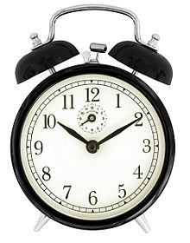


Only the goalkeeper to beat. The keeper was huge and the net looked tiny.
Could Willy do it?



He ran and chased and harried, but no-one passed the ball to him. He was never picked for his team.


Willy stared at them with wonder. When he looked up, there was no-one there.

